Solidity Smart Audit Report

Audit conducted on HedgePay Smart Contract

0xc75aa1fa199eac5adabc832ea4522cff6dfd521a

**Scope of the audit** **3**

Security Scope 3

General Code Quality 3

**Auditing Methods Used** **3**

**Assessing Possible Issues** **4**

Low level Severity Issues 4

Medium level Severity issues 4

High level Severity issues 4

**Code Base General Issues Report** **5**

Issues Found: 5

Front running 6

**Manual Code Inspection** **6**

Issues Found: 6

# 

# Scope of the audit

This Audit Report mainly focuses on the overall security of the SPIN token Smart Contract. This audit was conducted with rigorous attention to the general implementation of the contract and by examining the overall architectural layout of the software implementation. The reliability and correctness of this smart contract’s codebase are being assessed.

## Security Scope

Identifying security related issues within each contract and the system of contract.

## General Code Quality

A full assessment of the code quality and general software architecture patterns and best practices used.

# Auditing Methods Used

Rigorous testing of the project has been performed. Detailed code base analysis was conducted, reviewing the smart contract architecture to ensure it is structured and safe.

A detailed, line by line inspection of the codebase was conducted to find any potential security vulnerabilities such as denial of service attacks, race conditions, transaction-ordering dependence, timestamp dependence, and denial of service attacks.

Automated and manual testing was employed that included:

– Analysis of on-chain data security

– Analysis of the code in-depth and detailed, manual review of the code, line-by-line.

– Deployment of the code on an in-house testnet blockchain and running live tests●

– Determining failure preparations and if worst-case scenario protocols are in place

– Analysis of any third-party code use and verifying the overall security of this

Tools Used:

Remix IDE, Ganache, Solhint, VScode, Mythril, Contract Library Hardhat

# Assessing Possible Issues

Any issue detected during the conduction of this audit will be categorized under one of 4 severity levels: low, medium and high.

## Low level Severity Issues

Issues that do not pose any serious threat to the functionality of the software

## Medium level Severity issues

Issues that can cause potential problems to the overall health of the software application but that can be fixed without having any breaking changes on the current functionality

## High level Severity issues

Critical issues that affect the smart contract’s overall performance and functionality. These issues should be fixed urgently.

# Code Base General Issues Report

General issues that were found during manual and automatic assessments

| **No** | **Issue Verification** | **Status** |
| --- | --- | --- |
| 1 | Compiler warnings | Passed |
| 2 | Reentrancy and Race Conditions. | Passed |
| 3 | Possible delays in data delivery. | Passed |
| 4 | Oracle calls. | Passed |
| 5 | Front running. | Passed |
| 6 | DoS with block gas limit. | Passed |
| 7 | DoS with Revert. | Passed |
| 8 | Timestamp dependence. | Passed |
| 9 | Methods execution permissions. | Passed |
| 10 | Economy model. | Passed |
| 11 | The impact of the exchange rate on the logic. | Passed |
| 12 | Private user data leaks. | Passed |
| 13 | Scoping and Declarations. | Passed |
| 14 | Arithmetic accuracy. | Passed |

## Issues Found

| **Low Level Severity** | **Medium Level Severity** | **HighLevel Severity** |
| --- | --- | --- |
| 0 | 1 | 0 |

## Contract Dependency Graph

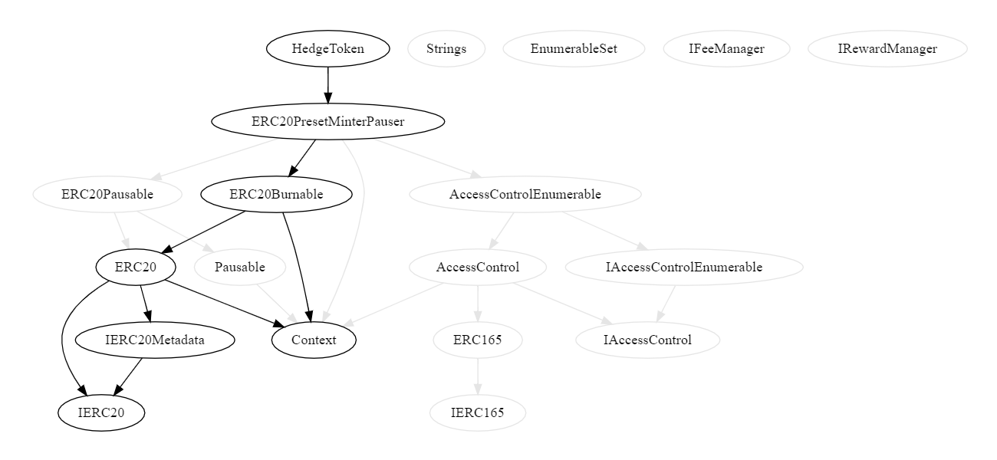

# Manual Code Inspection

The code of the target contract and its dependencies was reviewed, deployed and manually tested by our developers.

| **No** | **Contract** | **Issues** |
| --- | --- | --- |
| 1 | HedgeToken | None |
| 2 | RewardManager | None |
| 3 | FeeManager | None |

## Issues Found

| **Low Level Severity** | **Medium Level Severity** | **HighLevel Severity** |
| --- | --- | --- |
| 0 | 0 | 0 |

## Inspections

Contract: HedgeToken

Address:[0xc75aa1fa199eac5adabc832ea4522cff6dfd521a](https://bscscan.com/address/0xc75aa1fa199eac5adabc832ea4522cff6dfd521a)

Issues: 0

Notes: ERC-20 Token, The owner can mint tokens

Contract: FeeManager

Address: [0xb1588ca2529ff4f1a8e21d6fe24ba6d0b6e000b0](https://bscscan.com/address/0xb1588ca2529ff4f1a8e21d6fe24ba6d0b6e000b0)

Issues: 0

Contract: RewardManager

Address: [0x020f50300c85ee89cfcd73e1a46d55e9e9a93844](https://bscscan.com/address/0x020f50300c85ee89cfcd73e1a46d55e9e9a93844)

Issues: 0

# 

# Access Control And Privileges

The contract uses a single owner access control system for setting contract specific parameters.

## Privileges

The owner can:

– Exclude Accounts from fee

– Set Fees

– Update the FeeProvider

– Update the RewardManager

– MintTokens

## Notes

The owner of this contract can censor/restrict parties from accessing this contract's functionality.

The owner can mint tokens up to `totalSupply` amount

# Conclusion

The HedgePay Smart contracts do not contain any high severity issues!

## Audit Score

| **Section** | **Score** |
| --- | --- |
| Codebase Security | 100% |
| Codebase Complexity and Practices | 100% |
| Owner Privileges And Control | 90% |
| **Overall Score** | **96%** |

# 

# Disclaimer

This is a limited report on our findings based on our analysis, in accordance with good industry practice as at the date of this report, in relation to cybersecurity vulnerabilities and issues in the framework and algorithms based on smart contracts, the details of which are set out in this report. In order to get a full view of our analysis, it is crucial for you to read the full report. While we have done our best in conducting our analysis and producing this report, it is important to note that you should not rely on this report and cannot claim against us on the basis of what it says or doesn’t say, or how we produced it, and it is important for you to conduct your own independent investigations before making any decisions. We go into more detail on this in the disclaimer below – please make sure to read it in full.

DISCLAIMER: By reading this report or any part of it, you agree to the terms of this disclaimer. If you do not agree to the terms, then please immediately cease reading this report, and delete and destroy any and all copies of this report downloaded and/or printed by you. This report is provided for information purposes only and on a non-reliance basis, and does not constitute investment advice. No one shall have any right to rely on the report or its contents, and HedgePay and its affiliates (including holding companies, shareholders, subsidiaries, employees, directors, officers and other representatives) (HedgePay ) owe no duty of care towards you or any other person, nor does HedgePay make any warranty or representation to any person on the accuracy or completeness of the report. The report is provided "as is", without any conditions, warranties or other terms of any kind except as set out in this disclaimer, and HedgePay hereby excludes all representations, warranties, conditions and other terms (including, without limitation, the warranties implied by law of satisfactory quality, fitness for purpose and the use of reasonable care and skill) which, but for this clause, might have effect in relation to the report. Except and only to the extent that it is prohibited by law, HedgePay hereby excludes all liability and responsibility, and neither you nor any other person shall have any claim against BlockAudit, for any amount or kind of loss or damage that may result to you or any other person (including without limitation, any direct, indirect, special, punitive, consequential or pure economic loss or damages, or any loss of income, profits, goodwill, data, contracts, use of money, or business interruption, and

whether in delict, tort (including without limitation negligence), contract, breach of statutory duty,

misrepresentation (whether innocent or negligent) or otherwise under any claim of any nature

whatsoever in any jurisdiction) in any way arising from or connected with this report and the use,

inability to use or the results of the use of this report, and any reliance on this report.

The analysis of the security is purely based on the smart contracts alone. No applications or operations were reviewed for security. No product code has been reviewed.